$$MS-E2112-Multivariate statistical analysis–Home exercise 11$$

$$Srikanth Gadicherla,546195$$

$$March 31st,2016$$

**1. RESEARCH QUESTION**

In this project, the breast tissue dataset was taken from the UCI repository [1]. The task at hand was classification of the given samples into their corresponding categories. The linear discriminant analysis was the technique used for accomplishing the task.

**2. DATA INSPECTION:**

This multivariate dataset contained 106 instances of breast tissue with the ten attributes namely I0 Impedivity at zero frequency, PA500 phase angle, HFS high-frequency slope, DA impedance, Area under spectrum, A/DA normalized area, MAX IP, DR distance, P length of spectral curve. The impedance (~resistance) of the freshly excised breast tissue were measured at different frequencies of 15.625, 31.25, 62.5, 125, 250, 500, 1000 KHz. The data samples were used to classify them into six groups i.e., carcinoma, fibro-adenoma, mastopathy, glandular, connective and adipose.

**2.1 Univariate Data Visualization:**

The data was visualized with the univariate component-wise scatter plots as the data was real continuous data. Figure 1 shows the scatter plot with the different classes with distinct colors with the combination of data distributions on the principal diagonal of the plot. The visualization was accomplished using the R’s ggplot2 package.

Initial thoughts from the plot is that because of the less data points the univariate distribution doesn’t reveal any distribution which could be assumed for the next steps of the analysis. Next, most of the groups in the data can’t be separated from the plots except the groups of adipose (salmon color) and connective (green color) and for some plots even the carcinoma (yellow color) group can separated while the other classes are seen over-lapping in most of the plots. The class adipose can be seen to be having outlier data samples.

The attributes I0-P and DA-DR are correlated respectively. This can be confirmed from the correlation plot which is plotted next.

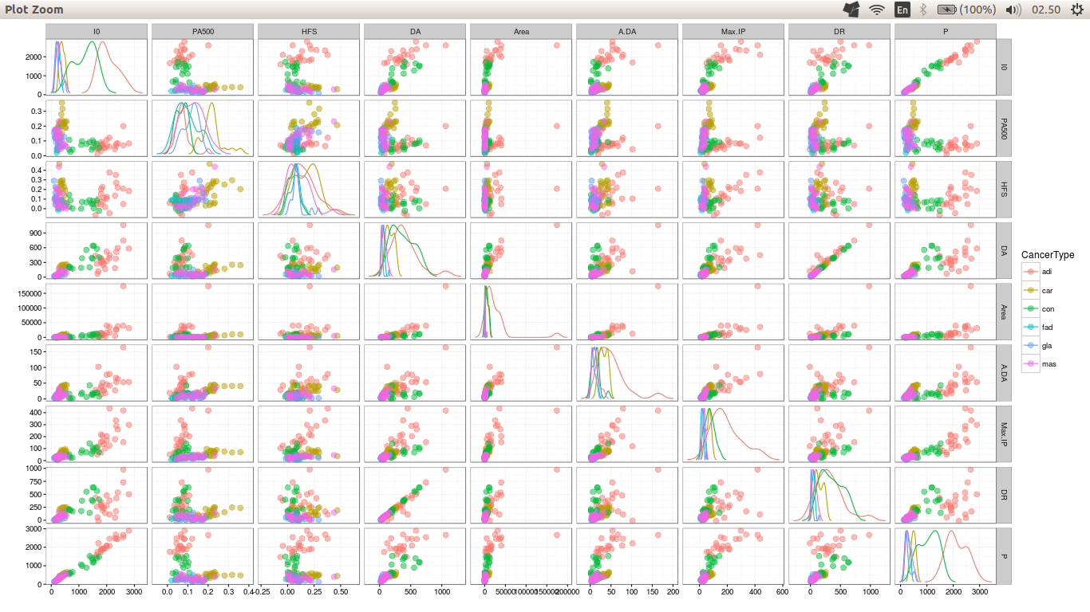

Figure 1: Scatter plot of the data.

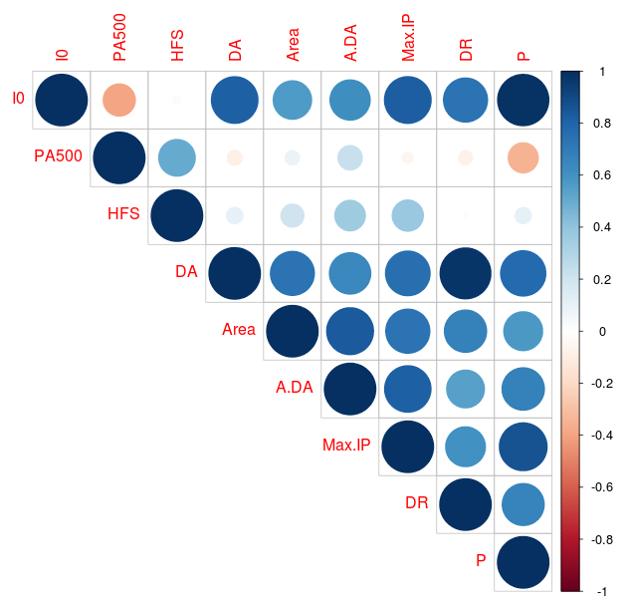

Figure 2: Correlation plot of the data.

Next, the bubble plot type correlation plot is presented for the data. As told above, it can be seen that attributes I0-P and DA-DR are highly correlated with correlation coefficients 0.988 and 0.974 respectively.

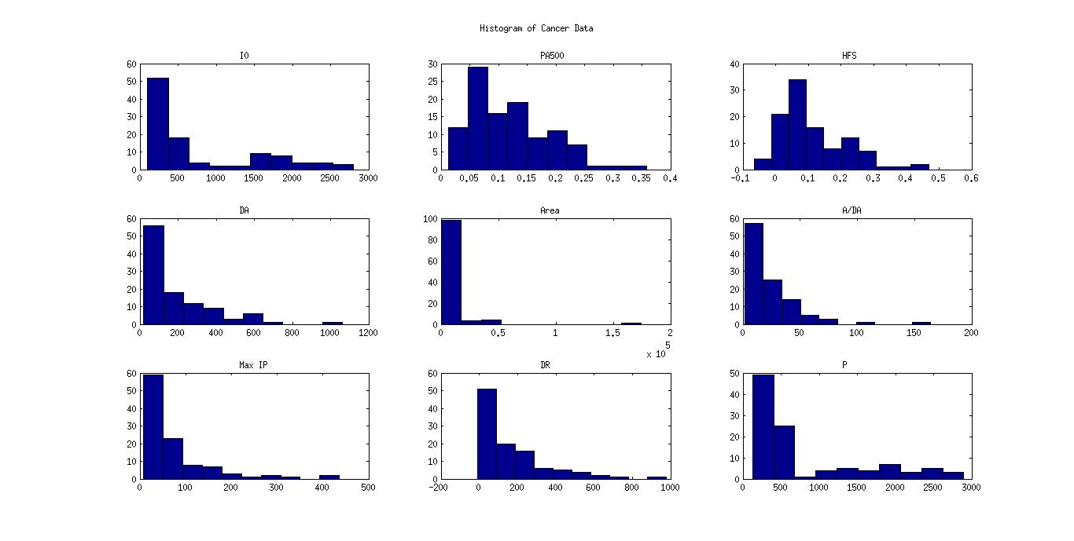

The next important aspect is to plot the histograms of the continuous attributes of the data.

Figure 3: Histogram of the data.

The observation from as told from the scatter plot is that most of the attributes are skewed having no proper distribution. For the attributes Area, A/DA, DR, Max IP and DA have the outlier points.

It can also be seen from the histogram that range of the attributes is highly varying from 10-1 to 10+3. So it’s logical to present the box plots for all the attributes of the data.

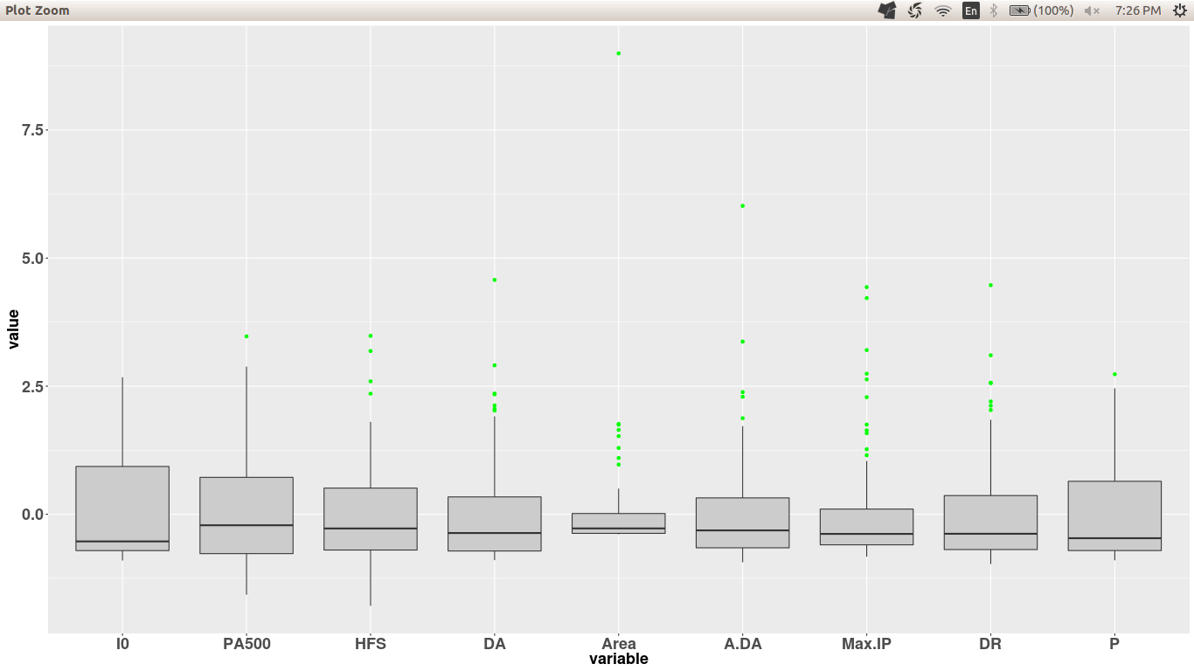

Figure 4: Histogram of the data.

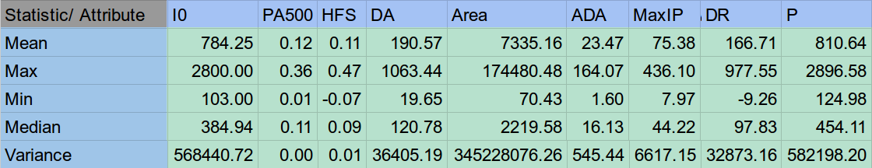Evident from the histogram that the long tails for the attributes in the histogram, the box plots has many outlying points. As the data had varying range, the data was normalized to get a sensible box plot.Last, the data statistics were found out. They included mean, maximum, minimum, median and variances of all the attributes.

Figure 5: Statistics of the data.

**APPENDIX**

A.1 Correlation Coefficients for the data

Below figure shows the correlation values for the data. The attributes with highest correlation have been highlighted.

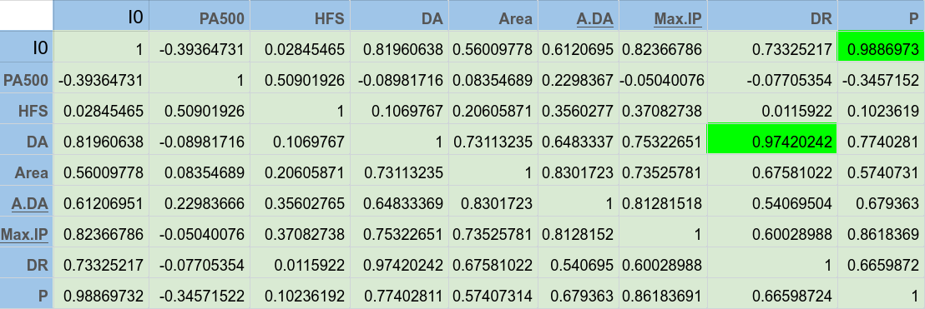

**REFERENCE**

### [1] J Jossinet (2010). UCI Machine Learning Repository [http:// http://archive.ics.uci.edu/ml/datasets/Breast+Tissue]. Irvine, CA: University of California, School of Information and Computer Science.

[2] Jossinet J (1996) Variability of impedivity in normal and pathological breast tissue. Med. & Biol. Eng. & Comput, 34: 346-350.

[3] Silva JE, Marques de Sá JP, Jossinet J (2000) Classification of Breast Tissue by Electrical Impedance Spectroscopy. Med & Bio Eng & Computing, 38:26-30.